DAA LAB — COMPLEXITY COMPARISON
Question: Prepare a complexity comparison table showing best-case, average-case, worst-case, and space complexities for all implemented algorithms.
Complexity Comparison
Algorithm | Best Case | Average Case | Worst Case | Space Complexity
Bubble Sort | O(n) | O(n²) | O(n²) | O(1)
Selection Sort | O(n²) | O(n²) | O(n²) | O(1)
Insertion Sort | O(n) | O(n²) | O(n²) | O(1)
Merge Sort | O(n log n) | O(n log n) | O(n log n) | O(n)
Quick Sort | O(n log n) | O(n log n) | O(n²) | O(n)*
Heap Sort | O(n log n) | O(n log n) | O(n log n) | O(n)*
Fibonacci Recursive | O(2ⁿ) | O(2ⁿ) | O(2ⁿ) | O(n)
Fibonacci Iterative | O(n) | O(n) | O(n) | O(1)
Fibonacci Dynamic Programming | O(n) | O(n) | O(n) | O(n)
* The Python implementations use list copies/temporary structures, so their practical auxiliary memory is O(n).
Code
def bubble_sort(a):
a=a.copy()
for i in range(len(a)-1):
swapped=False
for j in range(len(a)-i-1):
if a[j]>a[j+1]: a[j],a[j+1]=a[j+1],a[j]; swapped=True
if not swapped: break
return a

def selection_sort(a):
a=a.copy()
for i in range(len(a)-1):
k=min(range(i,len(a)),key=a.__getitem__)
a[i],a[k]=a[k],a[i]
return a

def insertion_sort(a):
a=a.copy()
for i in range(1,len(a)):
key=a[i]; j=i-1
while j>=0 and a[j]>key: a[j+1]=a[j]; j-=1
a[j+1]=key
return a

def merge_sort(a):
if len(a)<=1: return a.copy()
m=len(a)//2; l=merge_sort(a[:m]); r=merge_sort(a[m:])
out=[]; i=j=0
while i<len(l) and j<len(r):
if l[i]<=r[j]: out.append(l[i]); i+=1
else: out.append(r[j]); j+=1
return out+l[i:]+r[j:]

def quick_sort(a):
if len(a)<=1: return a.copy()
pivot=a[len(a)//2]
return quick_sort([x for x in a if x<pivot])+[x for x in a if x==pivot]+quick_sort([x for x in a if x>pivot])

def heap_sort(a):
import heapq
h=a.copy(); heapq.heapify(h)
return [heapq.heappop(h) for _ in range(len(h))]

if __name__=="__main__":
data=[64,25,12,22,11,90,34]
alg={"Bubble Sort":bubble_sort,"Selection Sort":selection_sort,"Insertion Sort":insertion_sort,"Merge Sort":merge_sort,"Quick Sort":quick_sort,"Heap Sort":heap_sort}
print("Python Sorting Algorithm Demonstration")
for n,f in alg.items(): print(f"{n:18}: {f(data)}")

def fibonacci_recursive(n):
if n<=1: return n
return fibonacci_recursive(n-1)+fibonacci_recursive(n-2)

def fibonacci_iterative(n):
a,b=0,1
for _ in range(n): a,b=b,a+b
return a

def fibonacci_dynamic(n):
if n<=1: return n
dp=[0]*(n+1); dp[1]=1
for i in range(2,n+1): dp[i]=dp[i-1]+dp[i-2]
return dp[n]

if __name__=="__main__":
n=20
print(f"Python Fibonacci Programs (n={n})")
print("Recursive :",fibonacci_recursive(n))
print("Iterative :",fibonacci_iterative(n))
print("Dynamic Programming :",fibonacci_dynamic(n))
Screenshot

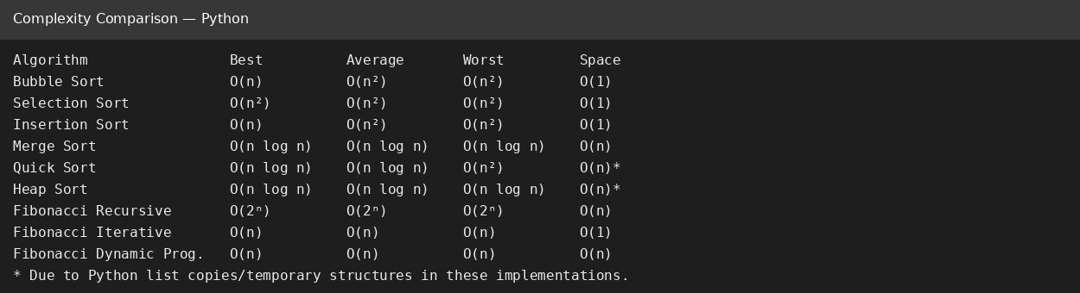
GitHub Link
____________________________________________
Paste the GitHub repository/file URL after uploading the Python code.

